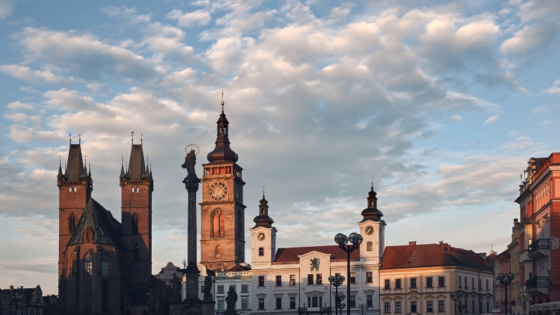**27tth ESPEN COURSE**

**in Clinical Nutrition and Metabolism**

**Hradec Králové, Czech Republic**

**9th to 15th October, 2022**

**“Clinical nutrition and intensive metabolic care is not a separate medical discipline, but combines all fields of clinical medicine in association with basic science. The progress in the clinical and scientific fields of clinical nutrition is enormous and the knowledge is more and more important that it has been in the past. The combination of basic science and its implementation in practice is fascinating.**

**ESPEN places great emphasis on educating the younger generation of doctors, and the annual interactive courses have become very popular. We hope that the information provided to you in this course of clinical nutrition will add new qualities to your work and give you more satisfaction in your everyday practice.**

**You have a unique opportunity to meet and discuss with top experts in clinical nutrition and intensive metabolic care in an inspiring and intellectual environment, as well as to exchange your experience, ideas and plans with the like-minded colleagues.**

**We are looking forward to meeting you in Hradec Kralove.“**

**Pavel Tesinsky**

**President, Czech Society of Clinical Nutrition and Intensive Metabolic Care**

**REGISTRATION - PROGRAMME - ACCOMODATION**

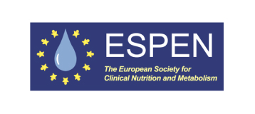

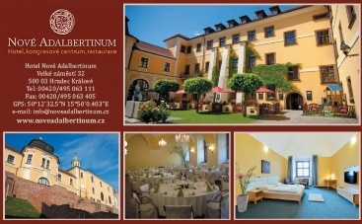

**Local Organising Committee**

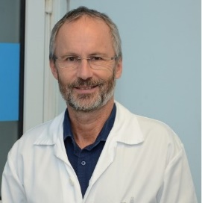

**Pavel Tesinsky, MD, Assoc Prof**

*President, Czech Society for Clinical Nutrition and Intensive Metabolic Care*

*Head, Division of Intensive Care, Clinical Nutrition and Metabolism*

*Charles University Hospital, Dept. of Medicine, Charles University in Prague*

[*pavel.tesinsky@fnkv.cz*](mailto:pavel.tesinsky@fnkv.cz)

*+420 603 422 663*

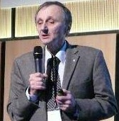

**Lubos Sobotka, MD, PhD, Prof**

*President Past, Czech Society for Clinical Nutrition and Intensive Metabolic Care*

*3rd Department of Medicine,* Metabolic Care & Gerontology *Medical Faculty Hradec Kralove, Charles University in Prague  
[pustik@lfhk.cuni.cz](mailto:pustik@lfhk.cuni.cz)*

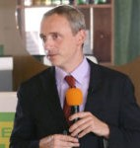

**Frantisek Novak, MD, PhD, Assoc Prof**

*Scientific Secretary, Czech Society for Clinical Nutrition and Intensive Metabolic Care*

*4th Department of Medicine – Department of Gastroenterology and Hepatology,*

*First Faculty of Medicine, Charles University in Prague*

*frantisek.novak@lf3.cuni.cz*



**Igor Khomenko**

*General Manager*

*Congress Hotel Nove Adalbertinum*

*Hradec Kralove*

[*manazer@noveadalbertinum.cz*](mailto:manazer@noveadalbertinum.cz)

*+420 603 449 530*

**Venue**

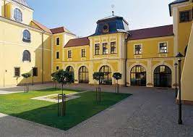

**Congress Hotel Nove Adalbertinum**

Velké náměstí 32  
500 03 Hradec Králové  
Czech Republic

[**http://www.noveadalbertinum.cz/en/**](http://www.noveadalbertinum.cz/en/)

**Faculty**

***Please note that program details as well as faculty may be subjects to change***

***Speakers´names are listed by time of appearance***

Local speakers

Pavel Tesinsky

Luboš Sobotka

Pavel Kohout

Frantisek Novak

Vladimir Teplan

Peter Szitanyi

Petr Benes

International speakers

Rocco Barazzoni

Regina Komsa

Peter Soeters

Laurence Genton

Najate Achamrah

Ronan Thibault

Remy Meier

Rosa Burgos

Aileen Hill

Stephane Schneider

Matthias Plauth

Stanislaw Klek

Alastair Forbes

Nada Rotovnik Kozjek

**Programme Schedule**

***Please note that program details as well as the faculty may be subjects to change***

**Sunday Oct 9, 2022**

**Arrival, registration, accommodation**

**17.00 – 19.30**

**Special introduction evening lectures:**

* Welcome address¨

*Pavel Tesinsky*

* ESPEN – the leader in research and education in clinical nutrition

*Rocco Barazzoni*

* ESPEN LLL Programme in Clinical Nutrition

*Regina Komsa*

* Basics of metabolism and individual nutritional needs

*Luboš Sobotka*

* Inflammation is more than a reaction to injury

*Peter Soeters*

* Which patient will profit form nutrition support

*Laurence Genton*

**20.00 – 22.00**

**Get together cocktail - dinner**

**Monday Oct 10, 2022**

**8.30 – 12.30**

**Nutritional physiology and pathophysiology**

* Undernutrition – consequences of short- and long-term undernutrition

*Laurence Genton*

* Obesity – metabolic aspects and consequences for clinical nutrition

*Rocco Barazzoni*

* Acute and chronic inflammation - consequences for nutrition support

*Peter Soeters*

* Growth Regeneration and Reparation – Nutritional consequences

*Luboš Sobotka*

* Diagnosis of malnutrition and indication of nutrition support

*Pavel Tesinsky*

**12.45 – 13.45**

**Lunch**

**14.00 – 17.00**

**Substrates for nutritional support**

* Carbohydrates and lipids

*Rocco Barazzoni*

* Proteins and amino acids

*Najate Achamrah*

* Micronutrients

*Ronan Thibault*

* Electrolytes and water

*Lubos Sobotka*

* Immunonutrients

*Ronan Thibault*

* Role of fiber in nutrition

*Remy Meier*

**17.00 – 18.00**

**Demonstration**

**18.00 – 19.30**

**Case report presentation & discussion (diagnosis of malnutrition)**

**19.30 Dinner**

**Tuesday Oct 11, 2022**

**8.00 – 9.00**

**Case report - general discussion**

**9.00 – 13.00**

**LLL course – Approach to Oral and Enteral Nutrition in Adults**

*Rocco Barazzoni, Pavel Kohout, Frantisek Novak*

**13.00 – 14.00**

**Lunch**

**14.00 – 17.00**

**Nutrition support in special clinical situations – I**

* Severe malnutrition

*Najate Achamrah*

* Acute and chronic pancreatitis

*Remy Meier*

* Diabetic patient

*TBA Rosa Burgos (rburgos@vhebron.net)*

* Trauma and intensive care

*Aileen Hill*

Obese patient (including patient after bariatric surgery)

*Ronan Thibault*

**17.00 – 18.00**

**Demonstration**

**18.00 – 19.30**

**Case report presentation & discussion**

**19.30 Dinner**

**Wednesday Oct 12, 2022**

**8.00 – 9.00**

**Case report general discussion**

**9.00 – 11.00**

**Nutrition support in special clinical situations – II**

* Perioperative nutrition

*Aileen Hill*

* Inflammatory bowel disease

*Stephane Schneider*

* Acute and chronic liver disease

*Matthias Plauth*

* Acute and chronic kidney disease

*Vladimir Teplan*

**11.30 – 20.00**

**Tour to Prague**

**20.30 Dinner**

**Thursday Oct 13**

**8.00 – 9.00**

**Case report general discussion**

**9.00 – 13.00**

**LLL course Approach to Parenteral Nutrition**

*Stanislaw Klek, Peter Szitanyi*

**13.00 – 14.00 Lunch**

**14.00 – 17.00**

**Nutrition support in special clinical situations – III**

* Gastrointestinal fistulas

*Stephane Schneider*

* Short bowel syndrome

*Alastair Forbes*

* Nutrition support and swallowing problems

*Frantisek Novak*

* Patient with cancer

*Nada Rotovnik Kozjek*

* Anorexia nervosa, eating disorders

*Alastair Forbes*

**17.00 – 18.00**

**Demonstration**

**18.00 – 19.30**

**Case report presentation & discussion**

**19.30 Dinner**

**Friday Oct 14, 2022**

**8.00 – 9.00**

**Case report general discussion**

**9.00 – 13.00**

**LLL course Nutrition support in Intensive Care**

*Stanislaw Klek, Pavel Tesinsky, Frantisek Novak*

1. **– 14.00**
2. **Lunch**

**14.00 – 17.00**

**Nutrition support in special clinical situations – IV**

* Nutrition support in neurological diseases

*Frantisek Novak*

* Nutrition support in neonates and children

*Peter Szitanyi*

* Nutrition during physiotherapy, exercise and sport

*Nada Rotovnik Kozjek*

* Home nutritional support

*Stanislav Klek*

* Life without Intestine – The experience of Czech patient organization

*TBA*

**18.00**

**Farewell dinner and party**

**Saturday Oct 15, 2022**

**8.00 – 10.00**

**Organization and legal aspects**

* Ethical and legal aspects

*Petr Benes*

* ESPEN Guidelines - how to implement and work with

*TBA*

* Nutrition support team

*TBA*

**11.00 – 12.30**

**Final test and general discussion**

**12.30-13.00**

**Certificates**

**13.00-14-00**

**Lunch**

**Departures**

**Registration**

**Registration fee**

ESPEN or national societies recommended person 150 EUR

*(Incl. registration, educational programme, accommodation*

*in double/sharing rooms for 5 nights, catering, 2 LLL courses,*

*exams, and social programme)*

Other participants 600 EUR

*(Incl. registration, educational programme, accommodation*

*in double/sharing rooms for 5 nights, catering, 2 LLL courses,*

*exams, and social programme)*

Travel costs or any other costs are covered by participant and are nor covered by ESPEN or local organizer.

**Applications and participants**

Physicians from various specialties as well as other professionals working in the field of clinical nutrition

(nutritionists, dietitians, pharmacists) can apply to participate in the course.

Deadline for the application is September 9, 2022

**Documents necessary for the registration**

1. Registration form

2. CV

3. letter of recommendation signed by the national society board or the ead of participant’s department

The compelete documents will be sent to the following address (please note the date of dellivery) or by email preferably:

**Mr. Igor Khomenko**

General Manager

Congress Hotel Nove Adalbertinum

Velke namesti 32

CZ-500 01 Hradec Kralove

Czech Republic, EU

[manazer@noveadalbertinum.cz](mailto:manazer@noveadalbertinum.cz)

+420 603 449 530

After receiving the application, the confirmation letter will be sent to the applicant.

**About Hradec Kralove**

**https://en.wikipedia.org/wiki/Hradec_Kr%C3%A1lov%C3%A9**

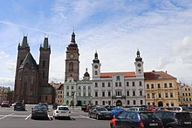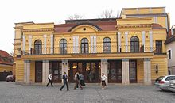

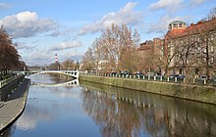

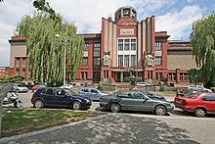

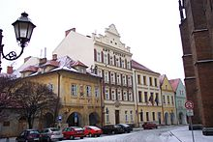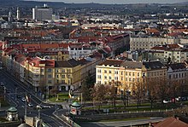

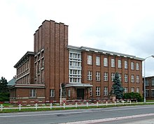

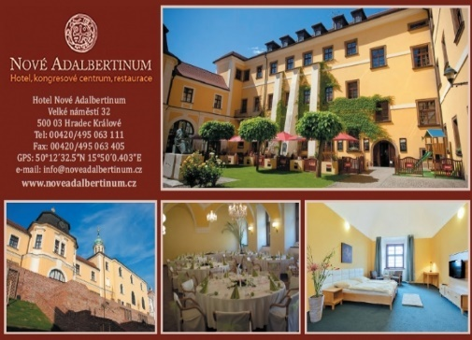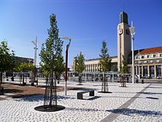

**Welcome address**

Dear Colleagues,

Metabolic care and clinical nutrition are crucial parts of modern medicine. The holistic approach based on an understanding of the integrative role of metabolism and metabolic pathways is essential for provision of comprehensive metabolic care.

Consistent education is essential for the dissemination of novel scientific results and their incorporation into clinical practice. The European Society for Clinical Nutrition and Metabolism (ESPEN) has accepted the challenge to organise educational activities for more than 45 years.

Since 1993 ESPEN has organised educational courses in clinical nutrition and that became basis of educational activities. Each course was modernised and enhanced by a team of enthusiastic and skilled speakers. Thanks to their ideas, the quality of the course rose and it became even more useful for students, physicians, dieticians. The reputation of these courses rose and it has been attended by students from whole Word. Since 2006 the Life Long Learning (LLL) program was implemented, that further improved educational program of the course. Most of speakers are leaders in the field and, together, they represent the best specialists in metabolic care and nutrition.

This year´s ESPEN course is organised in the historic city of Hradec Kralove. We are sure that informal meetings with experts and opinion leaders will stimulate your interest in research and science in the field of clinical nutrition and metabolic care.

We are happy to invite you to join this course.

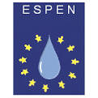Pavel Tesinsky

Lubos Sobotka

Frantisek Novak